
TRIBHUVAN UNIVERSITY
INSTITUTE OF SCIENCE AND TECHNOLOGY

A Project Proposal On
RESUME-DRIVEN ADAPTIVE INTERVIEW PRACTICE SYSTEM

Submitted To:
DEPARTMENT OF CSIT
NATIONAL COLLEGE OF COMPUTER STUDIES(NCCS)
PAKNAJOL, KATHMANDU

In partial fulfilment of the requirements for the degree of Bachelors of Science in Computer Science and Information Technology (B.Sc. CSIT)

Submitted By:
Nabin Yonjan (79010733)

February, 2026

TABLE OF CONTENT
LIST OF FIGURES iii
1. INTRODUCTION 1
2. PROBLEM STATEMENT 1
3. OBJECTIVES 2
4. SCOPE AND LIMITATION 2
4.1. Scope 2
4.2. Limitations 2
5. METHODOLOGY 3
5.1. Study of Existing Systems / Literature Review 3
5.2. Feasibility Study 4
5.2.1 Technical Feasibility 4
5.2.2. Operational Feasibility 4
5.2.3. Economical Feasibility 4
5.2.4 Schedule (Gantt Chart) 4
5.3. High-Level Design of Proposed System 5
5.3.1 System Modules 5
5.3.2 System Workflow 5
5.3.3 Description of Algorithms 6
6. EXPECTED OUTCOMES 8
7. REFERENCES 9

LIST OF FIGURES
Figure 1:Gantt Chart 4
Figure 2:Flow Chart 5

1. INTRODUCTION

Interview preparation is very crucial for students and job seekers who want to enter the technical world. However, most interview practice systems provide the same set of questions to every candidate. They do not personalize the interview by considering the student’s skill level, experience, or background, which results in limited feedback on interview preparation.

Recent advancements in natural language processing (NLP) and artificial intelligence (AI) have led to the development of many systems for interview preparation and resume analysis. These tools improve learning and preparation efficiency by extracting skills from resumes and helping students practice interview questions in an organized manner [1][2]. Still, many existing systems do not offer explicit skill-wise interview sessions or adjust question difficulty according to user performance. To overcome these limitations, this project proposes a web-based adaptive interview practice and skill assessment system that analyzes resumes, conducts performance-, skill-, and experience-based interview sessions, and provides overall feedback to enhance interview readiness.

2. PROBLEM STATEMENT
Many existing interview platforms provide only a fixed set of interview questions, which may not be efficient for all kinds of job seekers. These platforms rely on generic, non-personalized questions that fail to reflect an individual’s skills or experience. They do not conduct interview sessions based on the candidate’s skills, experience, answering pattern, or background. As a result, candidates often spend time practicing irrelevant questions and receive limited or generalized feedback. Furthermore, current systems lack adaptive question difficulty selection in real time based on user performance.

To overcome these kinds of problems, this project proposes a resume-driven adaptive interview preparation and skill assessment system.

3. OBJECTIVES
The primary objectives of this project are:
- To analyze the candidate’s resume for extracting information such as skills and experience.
- To provide personalized interview sessions using adaptive question selection and difficulty adjustment based on the candidate’s resume information and interview performance.
- To provide skill-wise feedback.

4. SCOPE AND LIMITATION

4.1. Scope
- The system is a web-based platform to help students and job seekers prepare for IT job interviews.
- Users upload their resumes, and the system analyzes skills and experience to generate personalized interview questions.
- Questions are grouped by skill and difficulty, and the difficulty is adjusted automatically based on user performance on each question’s answer.
- The system provides feedback and performance visualization to help users identify strengths and weaknesses.

4.2. Limitations
- This system is mainly focused on the IT field, so it is not suitable for all types of job interviews.
- Resume parsing uses basic keyword-based NLP, which may not handle complex resume structures accurately.
- The system uses a predefined set of questions, which may not cover every possible topic or scenario.
- The system is not powered by advanced machine learning models, which may limit accuracy in some cases.

5. METHODOLOGY
The methodology explains the steps to design and develop a resume-driven adaptive interview system, including requirement analysis, feasibility study, system design, and implementation planning.

5.1. Study of Existing Systems / Literature Review
In 2022, the AI-Powered Resume Analyzer and Interview Preparation System [1] proposed a framework for extracting skills from resumes and generating relevant interview questions. The system uses NLP techniques to analyze resumes, real time interview session with emotion detection and provides structured feedback on performance. However, it relies on static question sets and does not adjust question difficulty dynamically based on user performance.
In 2023, Harsh Koshti et al. [2] developed an AI-based interview preparation platform that offers personalized mock interviews and feedback using candidate skill profiles. While the system emphasizes structured practice, it lacks skill-wise performance evaluation and does not dynamically adapt to individual responses.
The AI-Based Resume Analyzer and Interview Simulator [3] uses NLP for resume parsing, machine learning for role mapping, and question generation to provide personalized interview simulations.
These studies show that current systems have gaps and point to the need for a platform that can analyze resumes, adapt questions based on performance, and give skill-wise feedback after end of interview session. This idea forms the basis of the proposed project.

5.2. Feasibility Study

5.2.1 Technical Feasibility
This project is technically possible because it uses common and easy-to-use technologies and algorithms. The system is web-based and made with HTML, CSS, JavaScript, and Python for the backend. It uses MySQL to save questions, user scores, and resume data. A resume parser reads the text and finds important keywords, while an adaptive algorithm changes the question difficulty based on how the user is doing.

5.2.2. Operational Feasibility
The system is easy to use and web-based, so anyone can access it from a browser. Users can upload resumes, practice questions, and get feedback without technical skills. Adaptive questions and performance charts help track progress and make practice more effective.

5.2.3. Economical Feasibility
I don't have to pay for hosting because I am working on my project on my own laptops and are setting up the website and backend on localhost. Therefore, our project is financially viable.

5.2.4 Schedule (Gantt Chart)
I have calculated the time required for completing this project. Time is separated for each of the work that is to be included into the project.

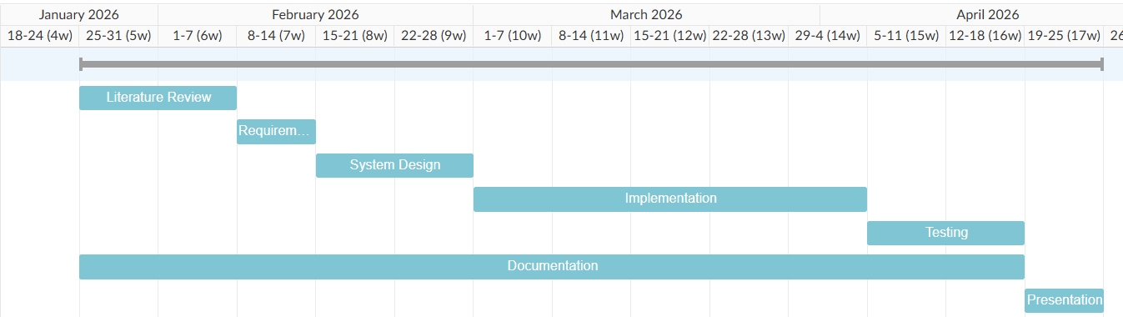
Figure 1:Gantt Chart

5.3. High-Level Design of Proposed System

5.3.1 System Modules
- User Interface – Login, resume upload, practice questions, feedback
- Resume Parsing (Custom + NLP) – Extract & analyze skills and experience from resumes
- Question Bank – Store questions by skill, difficulty and experience
- Adaptive Question Selection – Choose questions based on PerformanceScore
- Feedback & Skill Classification – Skill-wise performance, charts, proficiency levels
- Database (MySQL) – Stores users, resumes, questions, and results

5.3.2 System Workflow

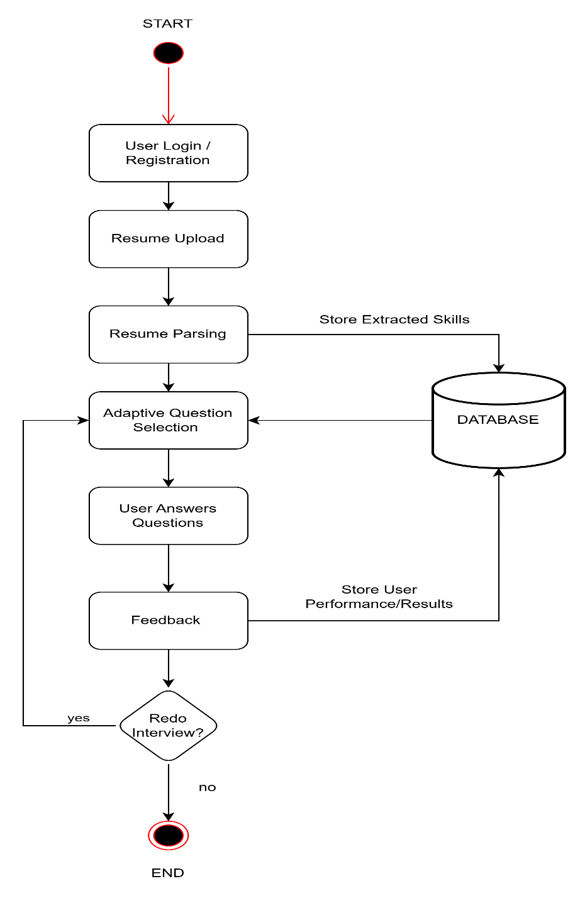
Figure 2:Flow Chart

5.3.3 Description of Algorithms
A. Resume Parsing Algorithm (Custom + NLP-enhanced)
- Read resume text (PDF/TXT) using lightweight libraries.
- Clean text (lowercase, remove punctuation, special characters).
- Tokenize words and phrases using custom logic.
- Optional NLP enhancement:
  - Named Entity Recognition (NER) for skills, degrees, job titles, tools.
  - Context-based skill detection (e.g., “developed ML model” → Machine Learning).
- Compare tokens/entities with predefined skill keywords and map to question categories.
- Store matched skills in the database.
B. Adaptive Question Selection Algorithm
For each skill:
- Start with an easy question.
- After user answers, calculate PerformanceScore:
PerformanceScore = α * Correctness + β * ResponseTime + γ * Confidence
- Decide next question difficulty:
NextDifficulty = CurrentDifficulty + f(PerformanceScore)
  - High PerformanceScore → harder question
  - Low PerformanceScore → easier or repeat question
- Continue until all questions are completed or session ends.
C. Skill Classification & Feedback Algorithm
For each skill:
- Calculate percentage of correct answers.
- Assign proficiency:
  - ≥80% → Strong
  - 50–79% → Medium
  - <50% → Weak
- Display results using visual charts or tables.

6. EXPECTED OUTCOMES
The expected outcomes of proposed system are:
- The system will successfully analyze uploaded resumes and extract candidates’ technical skills and experience.
- Users will receive personalized interview questions based on resume analysis.
- Question difficulty will be adjusted according to the candidate’s performance on each one.
- The system will provide clear, skill-wise feedback highlighting strengths and weaknesses.

7. REFERENCES

[1] | P. K. R. P. K. B. P. A. K. V. V. V. Ramesh B E, "ijraset," [Online]. Available: https://www.ijraset.com/research-paper/ai-powered-resume-analyzer-and-interview-preparation-system. [Accessed 1 2 2026].
[2] | P. G. R. P. P. K. S. T. Harsh Koshti, "journaljerr," [Online]. Available: https://journaljerr.com/index.php/JERR/article/view/1489/3223. [Accessed 1 February 2026].
[3] | M. M. R. M. J. P. P. N. S. R. L. Mayank Chauhan, "zenodo," [Online]. Available: https://zenodo.org/records/17875851. [Accessed 1 February 2026].

